

**10011**

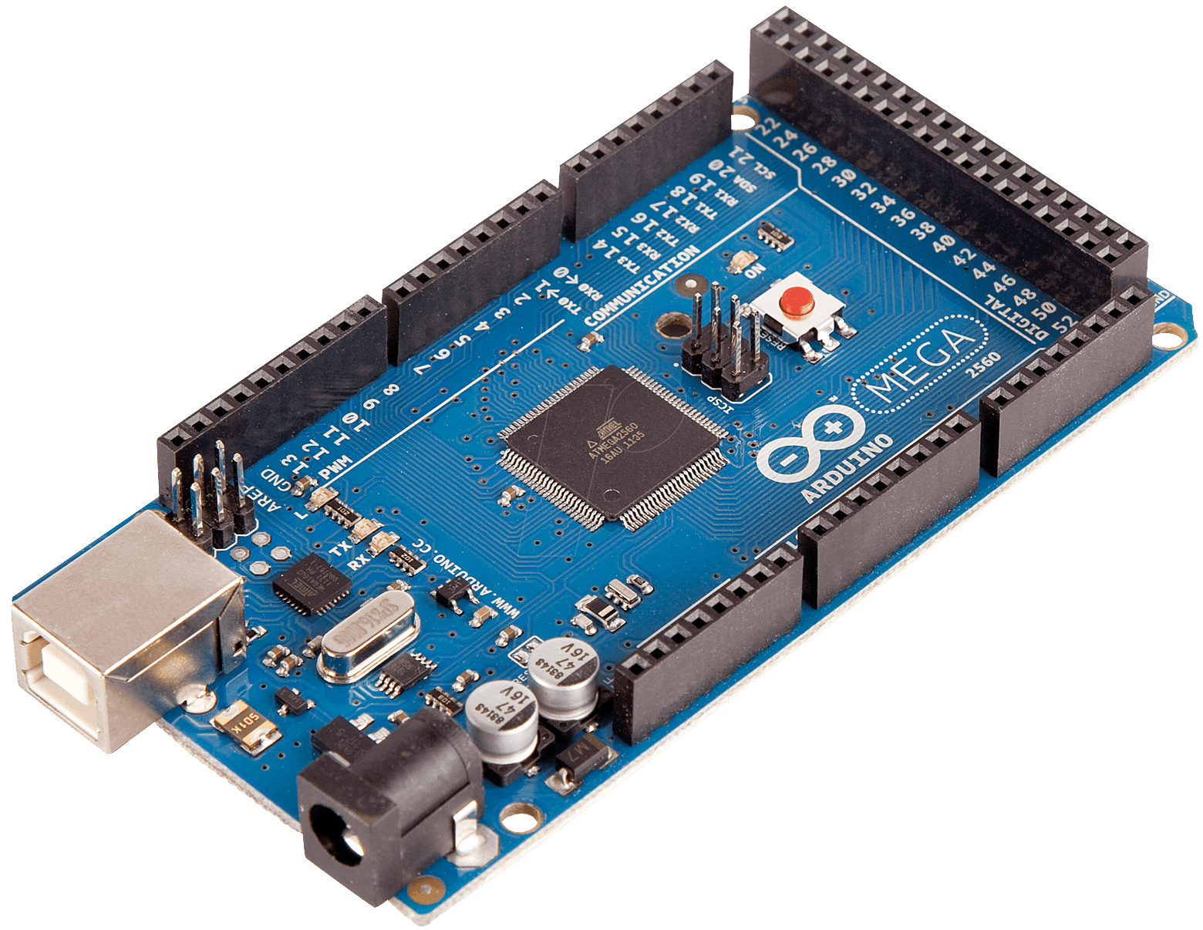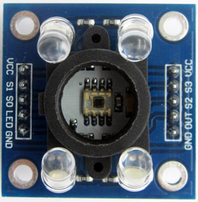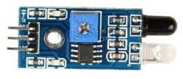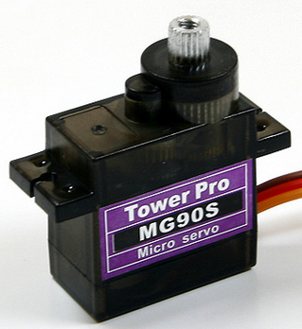

**Input Marbles**

**Detecting**

**Filter**

**Red**

**Blue**

**Green**

**Purple**

**Pink**

**Desktop Application**

**Output**





**Input Marbles**

**Detecting**

**Desktop Application**

**10011**

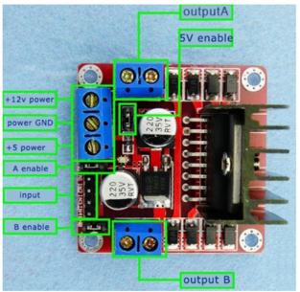

**Filter**

**Blue**

**Green**

**Purple**

**Pink**

**Red**

**Output**

**Input Marbles**

**Detecting**

**Filter**

**Red**

**Blue**

**Green**

**Purple**

**Pink**

**Desktop Application**

**Output**